Bluebonnet Learning Secondary Math Guided Notes

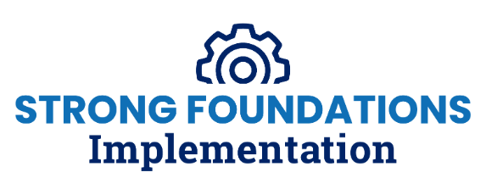
Teacher Lesson Internalization

The outline within this document is meant for participants to personalize as they take notes while engaging in the learning. Headings in blue throughout the outline mirror the sections identified within the session agenda, and subheadings in black align with slide titles.

Introduction
We’re glad you’re here!
Please access your copies of:
- Lesson Internalization Protocol
- The annotated lesson example
- The Anchor Lesson for the session: Grade 6 Module 1 Lesson 2

Objectives
During the session, you will:
- Describe the impact of the steps of the protocol
- Explain the importance of lesson internalization in supporting the implementation of high-quality instructional materials
- Prepare a lesson using the Lesson Internalization Protocol

Connection to Teacher Competencies

Essential Questions
- What are the benefits of completing a lesson internalization? ​
- What connections can you make between lesson internalization, the protocol, and student impact?​

Based on the objectives and essential questions, how do you think this session will contribute to mastery of Competency #1?​

Lesson Internalization Protocol
Anchoring in the Lesson Internalization Protocol
Directions
- Open the Lesson Internalization Protocol and the sample Lesson Internalization Protocol Framework.
- Read through the Protocol and skim through the lesson
- Consider and be ready to share
- How does this protocol support lesson planning and instructional effectiveness?

- What challenges might you face when internalizing lessons, and how can coaches support them?

Unpacking the Lesson Internalization Protocol
Step 1: Understand the Lesson Purpose and Objectives.
Consider and be ready to share:
- What is the essential purpose of step 1?

Step 2: Understand the sequence and pacing of activities.
Consider and be ready to share:
- What is the essential purpose of step 2?

Step 3: Prepare to teach each activity with an activity deep dive.
Consider and be ready to share:
- What is the essential purpose of step 3?

Step 4: Organize your resources.
Consider and be ready to share:
- What is the essential purpose of step 4?

Closing

Synthesize your Learning
- What are the benefits of completing a lesson internalization? ​

- What connections can you make between internalization, the protocol, and student impact?​

